

Thunder OAuth 2.0 / OIDC Component

Threat Model

Version: v1
Date: 2025-02-20
Email: security@wso2.com

Instructions
Threat Modeling exercises
- The respective team, product, or area lead is responsible for deciding whether threat modeling exercises are necessary for the relevant feature, application, or deployment.
  - First, please consult with the appropriate lead about the need to conduct a threat modeling exercise. The instructions below outline the process for scoping and carrying out threat model exercises.
- The respective team or area lead has the authority to make the final decision on how to address any risks identified during the threat modeling exercise.
  - The lead(s) should determine whether to mitigate the risk before going live/production, temporarily accept it and include it in the roadmap, ignore it by accepting the risk, transfer the risk, or even avoid it entirely.

- The security team is responsible for providing guidance on the threat model exercise, reviewing the threat model, and highlighting any potential threats that need to be considered.
  - The security team does not have the authority to grant approvals for threat models; this responsibility lies with the respective lead(s) after they have reviewed any risks associated with the development.

Threat Modeling Guidance
- Threat Modeling Guideline
- Threat modeling slides

- Threat modeling should ideally occur during the design phase or at least once you have a finalized use case, established interactions with other components, and identified actors and their usage. Waiting until the final stages to conduct the threat model could lead to delays in meeting deadlines and, in the worst cases, may require moving back to the design phase to resolve any identified design flaws.

- If you are developing new components that may require the processing of confidential data or could have the potential to impact business operations negatively. In that case, you will have to consider threats related to new elements and their interconnections and possible actor interactions.
  - If you are leveraging existing components, you will need to consider the threats related to the new additions and any threats or risks that may arise from dependencies (existing components) for your development.
    - If you are not introducing any new components or interactions that process confidential data or have the potential to impact current business operations negatively. In that case, there is no need to conduct a threat modeling exercise.
  - During Threat modeling, you would need to consider threats related to actor (unauthorized, authorized, and privileged) actions (creations, modifications, deletions, grants, revocations, etc) and possible negative impacts on the system, other components, and data.

- When you have created the threat model, send it to security-leads-group@wso2.com; please allow 2 working days for the security team to review it offline (please grant edit or commenter access to sc-team@wso2.com) and add comments before scheduling a threat model review meeting to save time and effort. It would be better to avoid Monday and Friday when scheduling threat model meetings unless it is urgent. Please let us know if you need urgent threat model reviews.

- If you have any questions, please contact Udith Wickramasuriyaor Ayoma Wijethunga

Table of Contents

Instructions 2
Table of Contents 3
Revision History 3
Introduction 4
Architecture Diagram 4
Data Flow or Sequence Diagram 5
Actors and Resources 6
Trust Boundaries 7
Threats and Mitigations 8
Inherited or Out-Scope Risks 8
Interactions 9
[XX]: [Interaction Name] 9
[XX]: [Interaction Name] 11
Security Considerations 12
Privacy Considerations 14
Threat Model Review 15
Risk registry entries 15
Document lifecycle 15
Appendix 16

[Please regenerate the table of contents]

Revision History
Version | Release Date | Contributors / Authors | Summary of Changes
v1.0 | 2025-02-24 | Thunder Team | Initial version — Complete OAuth 2.0/OIDC threat model

Introduction
Thunder is a lightweight user and identity management product providing authentication and authorization capabilities. This threat model covers the OAuth 2.0 / OpenID Connect (OIDC) authorization server component.
Scope:
• Authorization Code Grant with PKCE (RFC 7636)
• Client Credentials Grant
• Refresh Token Grant (with configurable rotation)
• Token Exchange Grant (RFC 8693) — delegation/impersonation with act claim
• Token Introspection (RFC 7662)
• OIDC UserInfo Endpoint (live user data)
• JWKS Endpoint (RSA, ECDSA P-256/P-384/P-521, EdDSA Ed25519)
• OAuth 2.0 / OIDC Discovery (RFC 8414)
• Dynamic Client Registration (RFC 7591)
• Client Authentication (client_secret_basic, client_secret_post, none)
• OIDC claims request parameter
• Resource Indicator (RFC 8707)
• Per-application token, claim, and scope configuration
• Observability events for token lifecycle
Standards: RFC 6749, 7636, 7662, 8414, 8693, 8707, OIDC Core 1.0, RFC 9700 (OAuth 2.0 Security BCP, Jan 2025).
Not yet implemented: Token Revocation (/oauth2/revoke), Logout (/oauth2/logout), Consent screen (TODO in codebase).
Associated docs: api/authentication.yaml, api/flow-execution.yaml, api/application.yaml, api/design.yaml

Architecture Diagram
The following diagram shows the high-level architecture of the Thunder OAuth 2.0 / OIDC module, including endpoints, internal components, dependencies, and data stores.
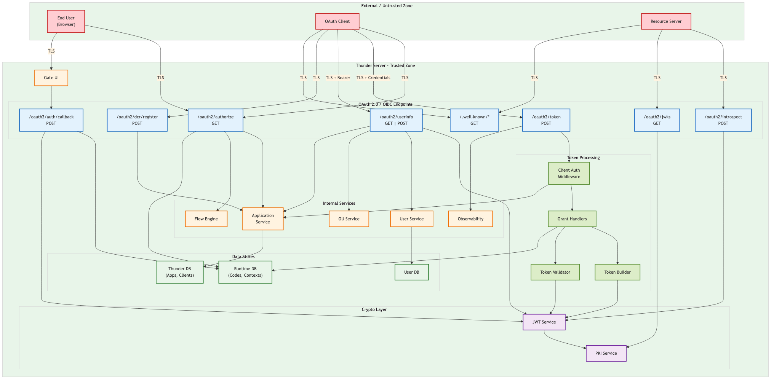

Data Flow or Sequence Diagram
The following sequence diagrams illustrate the key data flows.
DF-1: Authorization Code Grant with PKCE
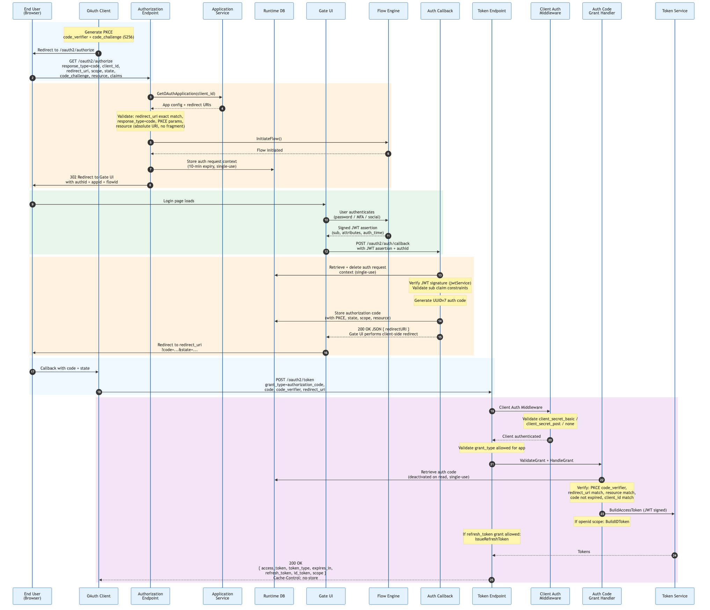
DF-2: Client Credentials Grant
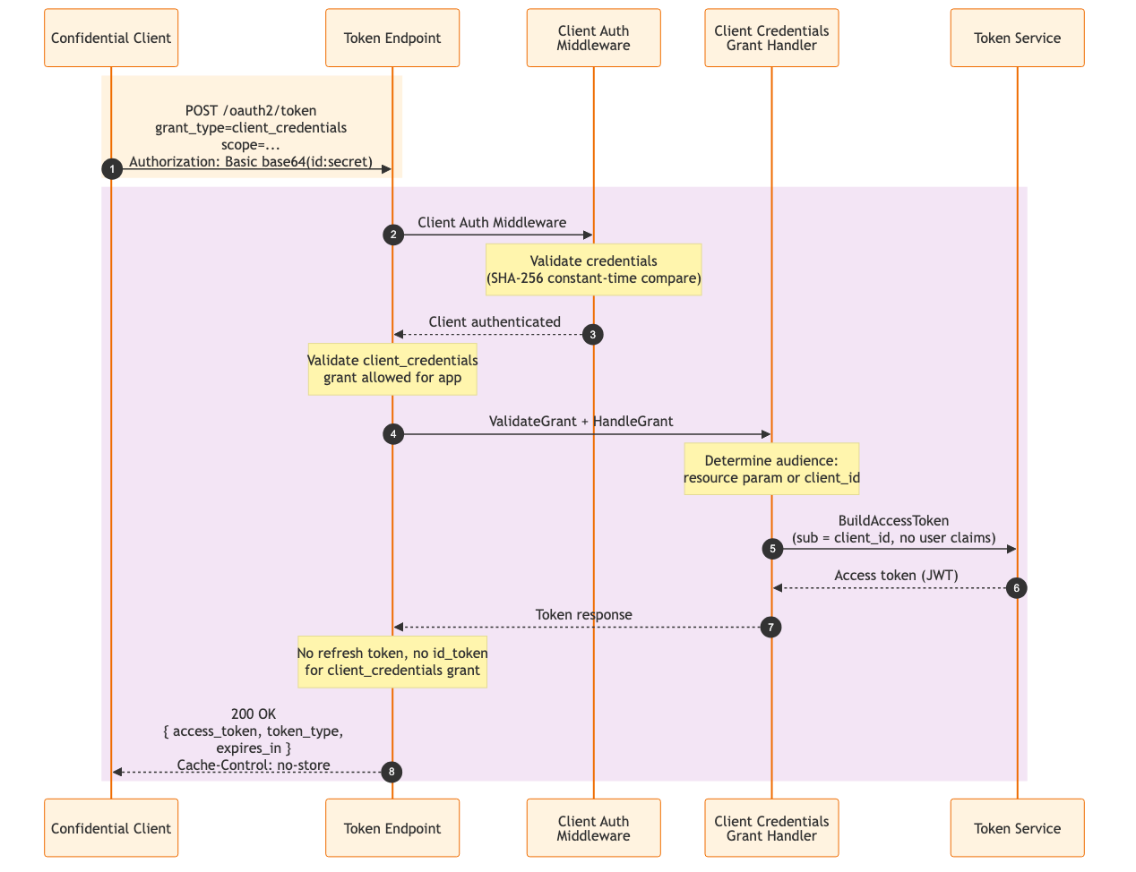
DF-3: Refresh Token Grant
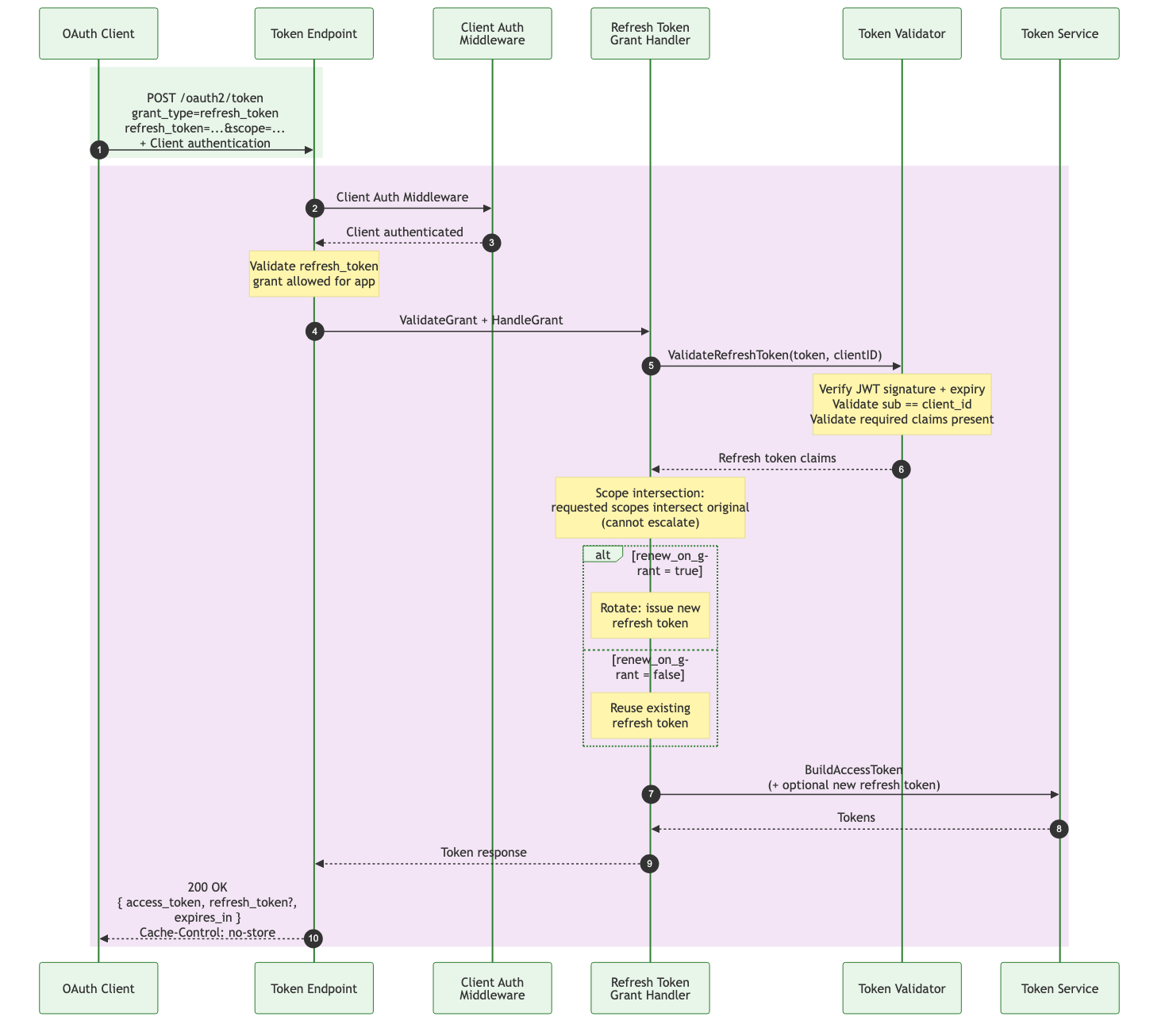
DF-4: Token Exchange (RFC 8693)
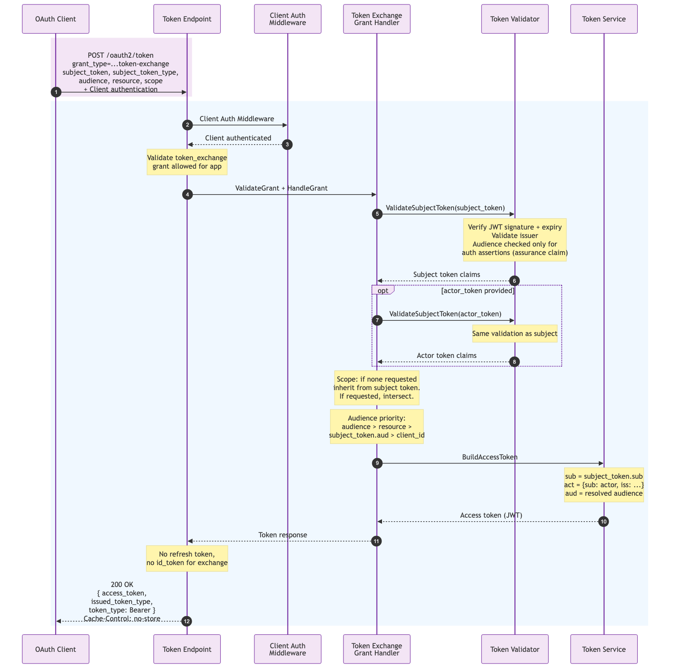

DFD notations to include in data flow or sequence diagrams
Boundary | Interaction Medium | Data Confidentiality
[B-EX-DP] External dependencies | [M-NT] Network interaction | [C-High] Highly confidential
[B-EX-EN] External entity (such as external APIs, IDPs, or systems) | [M-DB] Database interaction | [C-Medium] Medium confidential
[B-EX-CP] External component to the current feature, but code owned by WSO2 | [M-FS] File system interaction | [C-Low] Low confidential
 | [M-IN] Internal interaction

Actors and Resources
Actors
List the actors (malicious, authorized, and privileged) who would be interacting. Include information about what they are supposed to do.
Actor (Role) | Description | Roles or Permissions
End User (Resource Owner) | Authenticates via browser to authorize client access to their resources. | Initiate auth flow, authenticate, authorize/deny, access UserInfo
OAuth Client (Confidential) | Server-side app with client secret. Can securely store credentials. | Auth code, client credentials, refresh, token exchange grants
OAuth Client (Public) | SPA/native app that cannot securely store secrets. | Auth code + PKCE, refresh token grants
Resource Server | API server validating access tokens to protect resources. | Introspect tokens, validate JWT via JWKS
Admin / Developer | Manages OAuth apps and configuration. | Register apps (DCR/mgmt API), configure grants, redirect URIs, token policies
Web Attacker (A1, RFC 9700 Section 3) | Controls web servers. Creates redirect URIs, phishes users, manipulates browser flows. | Code interception, CSRF, phishing, open redirect, mix-up attacks
Network Attacker (A2, RFC 9700 Section 3) | Full network control: eavesdrop, intercept, modify, replay. Assumes TLS not broken. | MITM (if TLS misconfigured), token interception, TLS downgrade

Entitlement Matrix
The following table lists the actions for which each actor is permitted based on principles such as least privilege, need to know, and segregation of duties.

Actor | Auth Flow | Token Exchange | Introspect | UserInfo
End User | Yes (browser) | No | No | No
Confidential Client | Yes + secret | Yes | Yes* | Yes (Bearer)
Public Client | Yes + PKCE | No | Yes* | Yes (Bearer)
Resource Server | No | No | Yes* | No
Admin | No | No | No | No

Resources
These are the resources that you have control over
Assets | Description (usage, purpose, Authentication, and Authorizations, Security)
Authorization Endpoint | GET /oauth2/authorize — Validates client, redirect URI (exact match), PKCE, resource (RFC 8707), claims param; stores auth request context (10-min, single-use) in runtime DB.
Auth Callback | POST /oauth2/auth/callback — Verifies signed JWT assertion from Flow Engine; generates UUIDv7 auth code; validates sub claim constraints; redirects with 302.
Token Endpoint | POST /oauth2/token — Client Auth Middleware (Basic/Post/None, constant-time SHA-256). 4 grant types. Cache-Control: no-store, Pragma: no-cache. Publishes observability events.
Introspection | POST /oauth2/introspect — Validates tokens. GAP: No client auth. TODO: Token revocation/validity checks not implemented.
UserInfo | GET|POST /oauth2/userinfo — Bearer token required (openid scope). Fetches LIVE user data (attributes, groups ≤20, ouId, ouName). Rejects client_credentials tokens. Cache-Control: no-store.
JWKS | GET /oauth2/jwks — RSA, ECDSA (P-256/P-384/P-521), EdDSA (Ed25519). x5c chain, x5t, x5t#S256 thumbprints.
Discovery | /.well-known/openid-configuration + /.well-known/oauth-authorization-server — RFC 8414 / OIDC Discovery.
DCR | POST /oauth2/dcr/register — RFC 7591. jwks_uri/jwks (mutually exclusive). Auth: dcr.insecure=true → open; false → system permission. client_secret_expires_at=0 (never).
Authorization Codes | UUIDv7, single-use, configurable validity. Stored with PKCE challenge, redirect URI, scope, state, resource. Deactivated on first retrieval.
Auth Request Contexts | Ephemeral request data. 10-min hardcoded expiry. Single-use (deleted on read). Contains all OAuth params.
Access Tokens | JWT/RS256. Claims: sub, aud, iss, scope, client_id, grant_type, claims_req, claims_locales, user attributes, act (delegation). Per-app validity and user_attributes.
Refresh Tokens | JWT with access_token_sub, access_token_aud, metadata for re-derivation. Rotation via renew_on_grant config.
ID Tokens | OIDC JWT with auth_time, standard claims per scope, per-app filtered.
PKI Signing Keys | RSA/ECDSA/EdDSA private keys on filesystem. Multiple keys; preferred_key_id selects active.
Client Secrets | SHA-256 hashed. Constant-time comparison (crypto/subtle). Never expire (client_secret_expires_at=0).
Observability Events | TOKEN_ISSUANCE_STARTED/ISSUED/FAILED with client_id, grant_type, scope, error, duration_ms.
OIDC Claims/Scopes | Standard: openid, profile, email, phone, address. Per-app scope_claims override. claims parameter with essential/value/values. Custom: userType, ouId, ouName, ouHandle, groups.

Dependencies
These are the resources that you don’t have control over
Dependency | Description (usage, purpose, Authentication, and Authorizations, Security)
Application Service | internal/application — OAuth app config, credentials (SHA-256 constant-time), redirect URIs, grants, auth methods, token config, user_attributes, scope_claims.
Flow Engine | internal/flow/flowexec — User authentication (password, passwordless, MFA, social). Returns signed JWT assertion with identity and auth_time.
User Service | internal/user — User attributes (JSON), groups (≤20 via Group Service), ouId, ouName, ouHandle, userType.
PKI Service | internal/system/crypto/pki — X.509 certs and private keys (RSA/ECDSA/EdDSA).
JWT Service | internal/system/jose/jwt — JWT generation and verification. Configurable issuer, audience, leeway.
Database | internal/system/database — SQLite (dev) or PostgreSQL (prod). DEPLOYMENT_ID for multi-tenant isolation.
TLS | TLS 1.3 minimum in deployment.yaml. Server cert + key on filesystem.
Gate UI | frontend/apps/thunder-gate — Login/register/recovery UI.
Middleware | internal/system/middleware — CORS on all endpoints. security.GetPermissions for DCR auth.

Trust Boundaries
Trust boundaries of the OAuth/OIDC component:
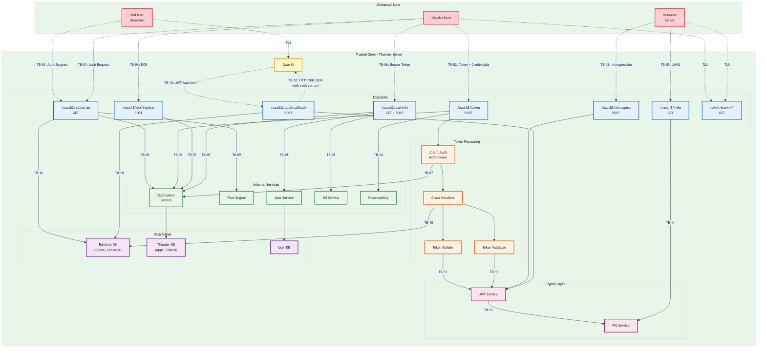
ID | Interaction Type | Interaction
TB-01 | Untrust→Trust | Browser → GET /oauth2/authorize (auth request over TLS)
TB-02 | Untrust→Trust | Client → POST /oauth2/token (with client auth over TLS)
TB-03 | Untrust→Trust | RS/Client → POST /oauth2/introspect (over TLS)
TB-04 | Untrust→Trust | External → POST /oauth2/dcr/register (over TLS)
TB-05 | Untrust→Trust | External → GET /oauth2/jwks (public keys over TLS)
TB-06 | Untrust→Trust | Client → GET|POST /oauth2/userinfo (Bearer token over TLS)
TB-07 | Trust→Trust | OAuth → Application Service (in-process, validates client config)
TB-08 | Trust→Trust | OAuth → User Service (in-process, user attributes/groups)
TB-09 | Trust→Trust | OAuth → Flow Engine (in-process, user authentication)
TB-10 | Internal | OAuth ↔ Runtime DB (auth codes, contexts; parameterized queries)
TB-11 | Internal | Token Service → PKI keys (filesystem, restricted permissions)
TB-12 | Trust→Untrust | Thunder → Gate UI: HTTP 200 JSON {redirect_uri} with auth code. Gate UI performs client-side redirect.
TB-13 | Untrust→Trust | Gate UI → POST /oauth2/auth/callback (JWT assertion over TLS)
TB-14 | Internal | Token Service → event system (observability events)

Threats and Mitigations

Inherited or Out-Scope Risks
List the risks that are beyond the scope of the threat model.
- Threats related to the malicious entity being able to manipulate the local network of the user (DNS/BGP/etc) to intercept or manipulate the payloads.
- • OS, container runtime, physical infrastructure threats.
• Flow Engine authentication mechanisms (separate threat model).
• Management API for application CRUD (separate).
• Compromised/rogue admin with direct DB access.
• L3/L4 DDoS.
• EOL software components in Go runtime or OS.
• Gate UI frontend (XSS, CSRF on login — separate).
• Consent flow threats (not yet implemented — TODO).
• Token revocation threats (/oauth2/revoke — not implemented).
• Logout/session management (/oauth2/logout — not implemented).
• PAR, Device Authorization Grant (not implemented).

Interactions

[I-01]: Authorization Request (End User → Authorization Endpoint)
Description
Browser GET to /oauth2/authorize with: response_type=code, client_id, redirect_uri, scope, state, code_challenge/method, resource (RFC 8707), claims, claims_locales (OIDC).
Processing flow:
1. Validates client_id existence; returns Gate error page if missing or unknown.
2. Retrieves OAuth app via ApplicationService.GetOAuthApplication(client_id).
3. Validates redirect_uri (exact match against registered URIs); error page if invalid.
4. Validates response_type=code and authorization_code grant allowed for app.
5. PKCE validation: code_challenge required for public clients (S256 or plain).
6. Resource parameter validated (absolute URI, no fragment) per RFC 8707.
7. Parses OIDC claims parameter (JSON with value/values mutual exclusivity).
8. Separates OIDC vs non-OIDC scopes; computes required user attributes.
9. Initiates auth flow via FlowExecService.InitiateFlow().
10. Stores auth request context in AUTHORIZATION_REQUEST table (10-min TTL, single-use).
11. Redirects (302) to Gate login page with authId, applicationId, flowId.
Error branching: Pre-redirect_uri errors (bad client_id, bad redirect_uri) go to Gate error page. Post-redirect_uri errors redirect to client redirect_uri with error + error_description + state. HTTP redirect_uri gets showInsecureWarning=true flag.

Assets Involved
Initiator | Intermediate | Target
End User (Browser) | OAuth Client (redirect) | Auth Endpoint → App Service → Runtime DB

Data Flow
See DF-1: Authorization Code Grant with PKCE, steps 1-6.

Access Control
No auth (public). Validates: client_id, redirect_uri exact match, response_type=code, PKCE required for public clients, resource as absolute URI w/o fragment.

Security Considerations
Area | Response | Comments
Data Confidentiality | High confidential [C-High]High [C-High] | Params: client_id, redirect_uri, scope, PKCE, state, resource, claims. Leakage enables code injection/CSRF.
Communication Medium | Network interaction [M-NT]Network [M-NT]
Transport Security | TLS EncryptionTLS 1.3
Authentication | No AuthenticationNone (public)
Accessibility | Publically AccessiblePublic

Threat Assessment
ID | Category | Threat | Materializable | Mitigations / Comment
1 | Spoofing | Redirect URI Manipulation (RFC 9700 Section 4.1): Redirects code to attacker. | No | Exact match. No wildcards. Re-verified at token exchange.
2 | Tampering | Code Injection (RFC 9700 Section 4.5): Stolen code injected into client callback. | No | PKCE enforced for public clients. Confidential clients need secret.
3 | Info Disc. | Code Leakage via Referer (RFC 9700 Section 4.2). | No | Single-use codes. PKCE binding.
4 | Info Disc. | Code in Browser History (RFC 9700 Section 4.3). | No | Single-use, short-lived. PKCE verifier not in URL.
5 | Spoofing | CSRF (RFC 9700 Section 4.7): Attacker initiates flow for victim. | No | State param + PKCE = CSRF protection per RFC 9700 Section 2.1.
6 | Spoofing | PKCE Downgrade (RFC 9700 Section 4.8): Strip code_challenge. | No | Required for public clients. Stored challenge requires verifier.
7 | Info Disc. | 307 Redirect (RFC 9700 Section 4.12): Forwards creds. | No | Uses 302 only.
8 | Tampering | Mix-Up (RFC 9700 Section 4.4): Client sends code to wrong AS. | No | Server metadata via /.well-known. iss claim in tokens.
9 | Elevation | Open Redirector (RFC 9700 Section 4.11.2). | No | Invalid URI → error page, not redirect.
10 | Info Disc. | Auth context in DB. | No | 10-min expiry, single-use, UUID authId.
11 | Spoofing | Redirect URI auto-select when omitted. | No | Only when 1 URI registered (per OAuth 2.1).
12 | Info Disc. | HTTP redirect_uri allows code interception. | Partial | showInsecureWarning flag set but http still allowed. Should reject http:// entirely per RFC 9700 Section 2.6. RISK REGISTRY.
13 | Tampering | resource param mismatch between auth and token. | No | Stored + re-validated at exchange. Absolute URI, no fragment.
14 | Info Disc. | claims param requests excessive PII. | No | Filtered by per-app user_attributes. sub constraint validated. essential enforcement TODO.
15 | Spoofing | Clickjacking on authorization endpoint (RFC 9700 Section 4.16). | Yes | RISK: No X-Frame-Options or CSP frame-ancestors header. RISK REGISTRY.
16 | Info Disc. | Missing Referrer-Policy header (RFC 9700 Section 4.2.4). | Yes | RISK: No Referrer-Policy header on authorization responses. RISK REGISTRY.
17 | Tampering | state parameter: no length or charset validation. | Partial | State is stored in DB and included in redirect URIs. No length limit could cause large DB entries. URL encoding provides some protection but no input validation.
18 | Spoofing | PKCE plain method accepted at authorization endpoint (RFC 9700 Section 2.1.1). | Yes | RISK: plain method is accepted and advertised in metadata. Allows code_challenge == code_verifier with no hashing. S256 should be mandatory. See I-14 T6. RISK REGISTRY.
19 | DoS | Authorization request flooding: no rate limit on /oauth2/authorize. | Yes | RISK: Each authorize request creates a new auth request in DB and initiates a flow. No rate limiting. Combined with no DB cleanup (I-10 T8), enables resource exhaustion. RISK REGISTRY.

[I-02]: Authorization Callback (Flow Engine → Auth Callback)
Description
Gate UI sends POST /oauth2/auth/callback with JSON body {authId, assertion}.
Processing flow:
1. Loads auth request context from AUTHORIZATION_REQUEST table (SELECT with expiry check, then DELETE — single-use, 10-min TTL enforced at query level).
2. Verifies JWT assertion signature via jwtService.VerifyJWT().
3. Decodes assertion claims: extracts sub, authorized_permissions, iat (becomes auth_time), and user attributes (excluding standard JWT claims).
4. Validates sub claim constraint if openid scope present (OIDC claims parameter sub matching).
5. Overwrites non-OIDC scopes with authorized_permissions from assertion.
6. Creates authorization code: generates UUIDv7 for code ID and code value, sets validity from OAuth.AuthorizationCode.ValidityPeriod config.
7. Persists auth code in AUTHORIZATION_CODE table with: PKCE challenge/method, redirect_uri, scope, state, resource, claims, claims_locales, user attributes.
8. Returns HTTP 200 JSON {redirect_uri: 'client-redirect?code=xxx&state=yyy'}.
IMPORTANT: The callback does NOT issue an HTTP 302 redirect. It returns JSON to Gate UI, which performs the client-side redirect via JavaScript.

Assets Involved
Initiator | Intermediate | Target
Gate UI (Browser) | Flow Engine (JWT) | Auth Callback → Runtime DB

Data Flow
See DF-1, steps 7-10.

Access Control
JWT assertion signed by server RSA key, verified via jwtService. Context single-use prevents replay.

Security Considerations
Area | Response | Comments
Data Confidentiality | High confidential [C-High]High [C-High] | JWT assertion with user identity. Generates UUIDv7 code. TLS 1.3. Internal PKI signed.
Communication Medium | Network interaction [M-NT]Network [M-NT]
Transport Security | TLS EncryptionTLS 1.3
Authentication | No AuthenticationJWT Assertion
Accessibility | Publically AccessiblePublic

Threat Assessment
ID | Category | Threat | Materializable | Mitigations / Comment
1 | Spoofing | Forged JWT Assertion. | No | Signed with server PKI key. Verified cryptographically via jwtService.
2 | Replay | JWT Assertion Replay. | No | Context single-use (deleted on read). 10-min expiry enforced at DB query level.
3 | Tampering | Sub Claim Bypass. | No | OIDC claims sub constraint validated against assertion sub.
4 | Spoofing | AuthId Guessing. | No | UUID, single-use, 10-min expiry. Deleted immediately after retrieval.
5 | Info Disc. | Auth code predictability (UUIDv7). | Partial | UUIDv7 has 48-bit timestamp + 74 random bits. Less entropy than a pure random token. RFC 6749 Section 10.10 recommends high entropy. 74 bits is non-trivial but weaker than recommended 128+ bits.
6 | Tampering | Authorized permissions escalation. | No | Scopes overwritten with assertion authorized_permissions, not merged.
7 | DoS | Auth context consumed before assertion verification. | Yes | RISK: loadAuthRequestContext deletes the auth request from the store BEFORE verifyAssertion is called. An attacker who obtains the authId can call the callback with an invalid assertion, consuming the auth context and causing the legitimate user's callback to fail. authId is in the Gate UI redirect URL. RISK REGISTRY.

[I-03]: Token Request (Client → Token Endpoint)
Description
POST /oauth2/token. Only endpoint wrapped with ClientAuthMiddleware.
Processing flow:
1. ClientAuth Middleware authenticates client (Basic/Post/None) with constant-time SHA-256.
2. Validates grant_type presence, valid enum, and supported by grant handler provider.
3. Validates grant_type is allowed for the specific app (per-app grant whitelist).
4. Publishes TOKEN_ISSUANCE_STARTED observability event.
5. Delegates to appropriate grant handler: ValidateGrant() then HandleGrant().
6. Scope validation via scopeValidator.ValidateScopes() (currently pass-through).
7. Issues refresh token if grant is authorization_code AND app allows refresh_token grant.
8. Publishes TOKEN_ISSUED or TOKEN_ISSUANCE_FAILED event with duration_ms.
Response headers: Cache-Control: no-store, Pragma: no-cache.
Error mapping: server_error=500, unauthorized_client=401, all others=400.
WWW-Authenticate: Basic returned on malformed Basic auth header.
Assets Involved
Initiator | Intermediate | Target
OAuth Client | Client Auth MW | Token Endpoint → Grant Handler → Token Service
Data Flow
See DF-1 steps 11-13, DF-2, DF-3, DF-4.
Access Control
client_secret_basic/post/none per-app config. Dual credential submission (header + body) rejected with invalid_request. Client must be authorized for both grant_type and auth method.
Security Considerations
Area | Response | Comments
Data Confidentiality | High [C-High] | Client creds + tokens
Communication Medium | Network [M-NT] | HTTPS POST
Transport Security | TLS 1.3
Authentication | Client Secret or None | Per-app config
Accessibility | Public
Threat Assessment
ID | Category | Threat | Materializable | Mitigations / Comment
1 | Spoofing | Client Impersonation. | No | Constant-time SHA-256. PKCE for public. Dual cred rejected.
2 | Replay | Auth Code Replay. | Yes | RISK: SELECT then UPDATE (non-atomic). Two concurrent requests can both read ACTIVE code before either deactivates. Revocation of tokens from replayed codes not implemented (TODO in codebase). RISK REGISTRY.
3 | Spoofing | redirect_uri mismatch at token. | No | Exact match against stored value.
4 | Spoofing | PKCE verifier brute force. | No | 43-128 chars, SHA-256 hashed. Infeasible.
5 | Info Disc. | Token response caching. | No | Cache-Control: no-store + Pragma: no-cache.
6 | Elevation | Scope escalation on refresh. | No | Scope intersection — cannot escalate.
7 | DoS | Token endpoint abuse / brute-force. | Yes | RISK: No rate limiting. Recommend implementing. RISK REGISTRY.
8 | Info Disc. | Client secret in logs. | No | MaskString used. No cleartext secrets logged.
9 | Spoofing | resource param mismatch. | No | Must match auth-time stored value.
10 | Info Disc. | Timing attack on client auth. | No | crypto/subtle.ConstantTimeCompare on SHA-256 hashes.
11 | Spoofing | Unauthorized grant type. | No | Per-app grant whitelist enforced.
12 | Info Disc. | Client secret stored in request context after authentication. | Partial | OAuthClientInfo stores plain-text ClientSecret in request context (clientauth/context.go). Copied into tokenRequest. Increases risk from memory dumps or debug logging.
13 | DoS | No request body size limits. | Yes | RISK: No http.MaxBytesReader on token endpoint. Unbounded POST bodies accepted. Recommend adding body size limits. RISK REGISTRY.
14 | Elevation | Client Credentials: no audience restriction enforcement. | Yes | RISK: DetermineAudience uses resource param or falls back to client_id. No validation that client is authorized for the requested audience/resource. Any CC client can get tokens for any audience. Combined with no-op scope validation, a client can get tokens for any audience with any scope. RISK REGISTRY.
15 | Spoofing | PKCE verification not constant-time. | Partial | validatePlainChallenge and validateS256Challenge use != (regular string comparison) instead of subtle.ConstantTimeCompare. Enables timing side-channel to infer code_verifier/challenge characters. Practical impact limited for S256 (hash comparison) but plain method is fully vulnerable.
16 | Tampering | No Content-Type validation on token endpoint. | Partial | r.ParseForm() accepts both application/x-www-form-urlencoded and multipart/form-data. RFC 6749 Section 4.3.2 requires Content-Type: application/x-www-form-urlencoded. Accepting multipart could enable unexpected behavior with encoding differences.

[I-04]: Token Introspection (RS → Introspection)
Description
POST /oauth2/introspect with form parameter 'token' (required) and optional 'token_type_hint'.
Processing flow:
1. Parses form data; validates token parameter presence.
2. Validates JWT via jwtService.VerifyJWT() (signature + expiry).
3. If invalid: returns {active: false} (per RFC 7662 — no error details leaked).
4. If valid: decodes JWT via jwt.DecodeJWT() and extracts claims.
5. Returns: scope, client_id, username, exp, iat, nbf, sub, aud, iss, jti, token_type=Bearer.
CRITICAL: No ClientAuthMiddleware applied. Any network caller can introspect any token.
token_type_hint is accepted in request but ignored in processing.
No token revocation checking (TODO in codebase).
Assets Involved
Initiator | Intermediate | Target
Resource Server / Any | — | Introspection → JWT Service (directly)
Data Flow
POST token. Thunder verifies JWT signature/expiry via jwtService, decodes and returns claims. Does NOT use TokenValidator — calls JWT Service directly.
Access Control
NO authentication or authorization. Any network caller can introspect any token. RFC 7662 Section 2.1 requires protected resource authentication.
Security Considerations
Area | Response | Comments
Data Confidentiality | Medium [C-Medium] | Token metadata + claims returned
Communication Medium | Network [M-NT] | HTTPS POST
Transport Security | TLS 1.3
Authentication | None (GAP) | No client auth MW
Accessibility | Public | Open to any caller
Threat Assessment
ID | Category | Threat | Materializable | Mitigations / Comment
1 | Info Disc. | Unauthenticated introspection (RFC 7662 Section 2.1). | Yes | RISK: Any caller can introspect any token. Require client auth. RISK REGISTRY.
2 | Spoofing | Token fishing: probe with guessed tokens. | No | JWTs high entropy. But endpoint auth would eliminate this.
3 | Tampering | Missing revocation check. | Yes | RISK: /oauth2/revoke not implemented. Cannot check revocation. RISK REGISTRY.
4 | Info Disc. | token_type_hint accepted but ignored. | No | No security impact. Hint only per RFC 7662.
5 | Info Disc. | Missing Cache-Control: no-store on introspection response. | Yes | RISK: Token metadata may be cached by proxies/browsers. Add Cache-Control: no-store.

[I-05]: UserInfo (Client → UserInfo Endpoint)
Description
GET|POST /oauth2/userinfo. Bearer token required (openid scope).
Processing flow:
1. Extracts Bearer token from Authorization header.
2. Verifies JWT via jwtService.VerifyJWT() (signature + expiry).
3. Decodes JWT and extracts: sub, scope, client_id, grant_type, claims_req, claims_locales.
4. Rejects client_credentials grant tokens (grant_type claim check).
5. Retrieves OAuth app config via ApplicationService.GetOAuthApplication(client_id).
6. Fetches LIVE user data from User Service: base attributes, groups (max 20 via Group Service), OU info (ouId, ouName, ouHandle via OU Service), userType.
7. Builds claims based on: OIDC scope-to-claims mapping, per-app user_info.user_attributes filter, per-app scope_claims overrides, and claims_req from access token.
8. Returns JSON with sub + filtered claims. Sets Cache-Control: no-store.
Error responses: 401 for invalid/expired token, 403 for missing openid scope or CC token.
Assets Involved
Initiator | Intermediate | Target
OAuth Client | — | UserInfo → User Service + OU Service → User DB
Data Flow
Validates JWT, extracts sub/scope/client_id/grant_type/claims_req, fetches live data from User Service and OU Service, filters by scope + per-app user_info.user_attributes config.
Access Control
Bearer token signature + expiry verified. client_credentials rejected (grant_type claim). openid scope required. Per-app user_attributes filtering limits data exposure.
Security Considerations
Area | Response | Comments
Data Confidentiality | High [C-High] | Returns PII; live DB data
Communication Medium | Network [M-NT] | HTTPS
Transport Security | TLS 1.3
Authentication | Bearer JWT | Signature + expiry validated
Accessibility | Public | Requires valid token
Threat Assessment
ID | Category | Threat | Materializable | Mitigations / Comment
1 | Info Disc. | Stolen Bearer token → PII (RFC 9700 Section 4.10). | Partial | Bearer tokens are inherently stealable if intercepted. TLS 1.3 + short-lived JWTs mitigate but do not eliminate. Consider DPoP/mTLS per RFC 9700 Section 2.2.1. RISK REGISTRY (see RR-06).
2 | Info Disc. | Excessive data exposure. | No | Filtered by scopes + per-app user_info.user_attributes.
3 | Elevation | CC token at UserInfo. | No | Explicitly rejected — checks grant_type claim.
4 | Info Disc. | Stale data: UserInfo differs from ID token. | No | By design: fetches live data. Clients should be aware.
5 | Info Disc. | Group membership leak. | No | Only if configured in per-app user_attributes. ≤20 groups.
6 | Info Disc. | claims_req parameter from access token expands response. | No | Claims still filtered by per-app user_attributes. Cannot request beyond app config.
7 | Info Disc. | Missing security response headers. | Partial | No HSTS, X-Content-Type-Options, or CSP headers. Cache-Control: no-store is set. Missing headers reduce defense-in-depth.

[I-06]: JWKS (External → JWKS Endpoint)
Description
GET /oauth2/jwks. Returns JWK Set with all public signing keys.
Processing flow:
1. Retrieves all certificates from CertificateService.GetCertificates().
2. Iterates over each certificate, determining key type (RSA, EC, OKP).
3. For each key, builds JWK with: kid (SHA-256 thumbprint), kty, use=sig, alg.
4. Adds x5c chain (base64 DER), x5t (SHA-1 thumbprint, base64url), x5t#S256 (SHA-256 thumbprint, base64url).
5. RSA keys include n, e. EC keys include crv (P-256/P-384/P-521), x, y. OKP keys include crv=Ed25519, x.
6. Returns JSON {keys: [...]} array.
NOTE: No caching headers set. Endpoint is regenerated on each request. kid is computed from certificate thumbprint (SHA-256), not configured. x5t uses SHA-1 (deprecated but still widely used for compatibility).
Assets Involved
Initiator | Intermediate | Target
RS / Client | — | JWKS → Certificate Service → PKI
Data Flow
GET request returns JWK Set with public keys. Keys loaded from PKI on each request.
Access Control
No auth (public). Keys are public by design. Private keys never exposed.
Security Considerations
Area | Response | Comments
Data Confidentiality | Public | Public keys only
Communication Medium | Network [M-NT] | HTTPS
Transport Security | TLS 1.3 | Prevents key injection
Authentication | None | Public endpoint
Accessibility | Public
Threat Assessment
ID | Category | Threat | Materializable | Mitigations / Comment
1 | Tampering | JWKS MITM: inject forged key. | No | TLS 1.3. x5c chain + x5t#S256 for verification.
2 | Info Disc. | Algorithm enumeration. | No | Public. Server enforces specific algs.
3 | Spoofing | Algorithm confusion (multi-key-type). | No | JWT kid matches specific key. No alg=none.
4 | Info Disc. | SHA-1 in x5t thumbprint. | No | SHA-1 used for compatibility only. x5t#S256 also provided. SHA-256 thumbprint is primary kid.
5 | DoS | No caching: repeated JWKS fetches hit PKI each time. | No | Lightweight operation. Consider adding Cache-Control header for high-traffic deployments.

[I-07]: Discovery (External → /.well-known/*)
Description
Two separate endpoints serving server metadata:
1. GET /.well-known/openid-configuration — OIDC Discovery 1.0 metadata.
2. GET /.well-known/oauth-authorization-server — RFC 8414 AS metadata.
Both endpoints build metadata dynamically from server config:
• issuer, authorization_endpoint, token_endpoint, userinfo_endpoint, jwks_uri
• introspection_endpoint, registration_endpoint
• response_types_supported: [code]
• grant_types_supported: [authorization_code, client_credentials, refresh_token, urn:ietf:params:oauth:grant-type:token-exchange]
• token_endpoint_auth_methods_supported: [client_secret_basic, client_secret_post, none]
• code_challenge_methods_supported: [S256, plain]
• scopes_supported (OIDC + non-OIDC from ScopeService)
• claims_supported, claims_parameter_supported: true
• subject_types_supported: [public]
Constants for /oauth2/revoke and /oauth2/logout defined but NOT registered as routes.
NOTE: userinfo_endpoint field exists in the metadata model (omitempty) but is NOT populated
in current responses. Clients must discover userinfo via token endpoint or documentation.
Assets Involved
Initiator | Intermediate | Target
Client / RS | — | Discovery Endpoints
Data Flow
GET returns JSON metadata document. Built dynamically from server runtime config.
Access Control
No auth (public per RFC 8414 / OIDC Discovery).
Security Considerations
Area | Response | Comments
Data Confidentiality | Public | Capabilities + URLs
Communication Medium | Network [M-NT] | HTTPS
Transport Security | TLS 1.3
Authentication | None | Public
Accessibility | Public
Threat Assessment
ID | Category | Threat | Materializable | Mitigations / Comment
1 | Tampering | Metadata MITM: redirect clients to malicious endpoints. | No | TLS 1.3. RFC 8414 metadata (RFC 9700 Section 2.6).
2 | Info Disc. | Feature enumeration. | No | Public by design.
3 | Tampering | Metadata mismatch between two endpoints. | No | Same builder function produces both. Consistent.
4 | Info Disc. | Advertised endpoints not implemented (revoke, logout). | Partial | Constants defined but routes not registered. Endpoints return 404. Could mislead clients into believing revocation is available when it is not.
5 | Info Disc. | Metadata advertises code_challenge_methods_supported: [S256, plain]. | Yes | RISK: Advertising plain method in metadata encourages clients to use it. RFC 9700 Section 2.1.1 recommends S256 only. Clients reading metadata may choose plain over S256. RISK REGISTRY (see RR-14).

[I-08]: DCR (External → DCR Endpoint)
Description
POST /oauth2/dcr/register. RFC 7591 Dynamic Client Registration.
Processing flow:
1. If dcr.insecure=false: checks security.GetPermissions for system-level permission.
2. Parses JSON request body with client metadata.
3. client_id auto-generated (UUID) — cannot be client-specified.
4. Public client auto-detection: if token_endpoint_auth_method=none, marks as public client.
5. Public clients auto-enforce: pkce_required=true. client_credentials grant removal
handled downstream by Application Service during app creation (not by DCR directly).
6. Validates: redirect_uris (required for auth_code), grant_types vs response_types consistency, auth_method supported, jwks/jwks_uri mutual exclusivity.
7. Maps jwks_uri/jwks to application certificates.
8. Generates client_secret (random), SHA-256 hashed before storage.
9. Creates application via ApplicationService.
10. Returns: client_id, client_secret, client_secret_expires_at=0 (never), plus echoed metadata. Additional fields: client_uri, logo_uri, tos_uri, policy_uri, contacts.
Assets Involved
Initiator | Intermediate | Target
Client / Dev | Permission Check | DCR → Application Service
Data Flow
POST metadata → validate → auto-detect public client → create app → return client_id + client_secret.
Access Control
dcr.insecure=false → system permission (security.GetPermissions). Validates: redirect_uris, grant_types, auth_method, response_types, jwks exclusivity. Public clients auto-enforced (PKCE required, no CC grant).
Security Considerations
Area | Response | Comments
Data Confidentiality | High [C-High] | Returns client_secret
Communication Medium | Network [M-NT] | HTTPS POST
Transport Security | TLS 1.3 | Secret over TLS only
Authentication | Configurable | insecure flag
Accessibility | Configurable
Threat Assessment
ID | Category | Threat | Materializable | Mitigations / Comment
1 | Spoofing | Unauth registration when dcr.insecure=true. | Yes | RISK: Open registration. Use insecure=false in prod. Initial access tokens per RFC 7591 Section 3. RISK REGISTRY.
2 | DoS | Registration flooding. | Yes | RISK: No rate limiting. RISK REGISTRY.
3 | Elevation | Excessive grants/scopes via DCR. | No | Validated against supported capabilities. Public clients auto-enforce PKCE.
4 | Info Disc. | client_secret in response; never expires. | No | Returned once over TLS. client_secret_expires_at=0 — recommend rotation support.
5 | Tampering | JWKS/JWKS_URI injection. | No | Mutually exclusive validation. Mapped to app certificates.
6 | Elevation | Public client requests client_credentials grant. | No | Auto-removed during public client detection. Cannot bypass.
7 | Spoofing | Client-specified client_id. | No | client_id is server-generated UUID. Client input ignored.
8 | DoS | No request body size limits. | Yes | RISK: No http.MaxBytesReader. DCR accepts unbounded JSON bodies. Combined with insecure mode (no auth), attacker can send arbitrarily large payloads to exhaust memory/storage. RISK REGISTRY.

[I-09]: Token Exchange (Client → Token Endpoint, RFC 8693)
Description
grant_type=urn:ietf:params:oauth:grant-type:token-exchange.
Processing flow:
1. Validates required params: subject_token, subject_token_type.
2. Verifies subject_token JWT (signature + expiry via jwtService).
3. If subject_token contains 'assurance' claim, treats as auth assertion with stricter validation:
• audience must match configured audience OR app_id.
• authorized_permissions claim used for scope (not requested scope).
4. Non-assertion tokens: audience priority = audience param > resource > subject_token aud > client_id.
5. If actor_token provided: verifies JWT, nests act claim chain in issued token.
6. Scope subsetting: requested scope intersected with subject token scope.
7. Builds new access token via tokenService with delegation act claim.
8. Returns: access_token, issued_token_type=urn:ietf:params:oauth:token-type:access_token, token_type=Bearer, expires_in, scope.
NOTE: External JWKS validation for subject_token not fully implemented (TODO in codebase). Currently only validates tokens signed by this server's keys.
Data Flow Diagram

Assets Involved
Initiator | Intermediate | Target
OAuth Client | Client Auth MW | Token Exchange Handler → Token Service
Data Flow
See DF-4: Token Exchange flow. Validates subject/actor JWTs, computes audience priority, detects auth assertions (assurance claim), subsets scope, builds new token with act claim.
Access Control
Client auth required. subject/actor tokens validated (sig, expiry, aud). Auth assertions: audience must match config or app_id. Scope cannot escalate.
Security Considerations
Area | Response | Comments
Data Confidentiality | High [C-High] | Existing + new tokens
Communication Medium | Network [M-NT] | HTTPS POST
Transport Security | TLS 1.3
Authentication | Client Secret | Required
Accessibility | Public | Requires valid creds
Threat Assessment
ID | Category | Threat | Materializable | Mitigations / Comment
1 | Elevation | Escalate via exchange. | No | Inherits subject. Scope equal or narrower. act chain tracked.
2 | Spoofing | Stolen subject_token reuse. | No | Client auth + token signature/expiry validation.
3 | Tampering | Audience manipulation. | No | Clear priority order. Strict for auth assertions.
4 | Spoofing | Forged actor_token. | No | JWT signature + expiry checked. act claim nests chain.
5 | Spoofing | Auth assertion abuse (assurance claim). | No | Stricter audience. authorized_permissions for scope.
6 | Elevation | External token accepted without JWKS validation. | Yes | RISK: Currently only validates tokens signed by this server. External JWKS TODO. RISK REGISTRY.
7 | Elevation | Scope escalation via requested_scope param. | No | Scope intersected with subject token. Cannot request more than subject has.
8 | Spoofing | Subject token decoded before signature verification. | Partial | ValidateSubjectToken first decodes JWT payload to extract issuer for key routing, then verifies signature. Issuer routing decision based on unverified claims. Currently mitigated by accepting only internal issuers, but if external issuers are added (TODO exists), this pattern becomes dangerous.
9 | Info Disc. | Error messages leak internal validation details. | Yes | RISK: Error response includes fmt.Sprintf('Invalid subject_token: %s', err.Error()) which leaks internal error messages about token structure, missing claims, signature failures, and issuer validation. RISK REGISTRY.

[I-10]: Database Operations (OAuth → DB)
Description
Internal data access for OAuth state management.
Tables:
• AUTHORIZATION_REQUEST: Stores auth request context (redirect_uri, scope, state, PKCE, resource, claims, claims_locales, oidc_scopes, non_oidc_scopes, response_type, user_attributes as JSON). 10-min TTL, single-use (deleted on read).
• AUTHORIZATION_CODE: Stores auth codes with all grant data (PKCE challenge/method, redirect_uri, scope, state, resource, claims, user_attributes as JSON). State machine: ACTIVE → INACTIVE on first use.
IMPORTANT: Auth code consumption (SELECT then UPDATE) and auth request consumption
(SELECT then DELETE) are non-atomic — no transaction wrapping. This creates a small
race condition window for concurrent requests with the same code/authId.
NOTE: Auth code SELECT query does NOT filter by STATE=ACTIVE in SQL; state validation
happens in the grant handler in-memory after retrieval.
All queries use parameterized SQL via DBQuery with unique IDs for traceability. DEPLOYMENT_ID included in all WHERE clauses as composite PK for multi-tenant isolation. Complex data (user_attributes, claims) stored as JSON blobs.
Assets Involved
Initiator | Intermediate | Target
OAuth Module | DBClient | Runtime DB / Thunder DB
Data Flow
Internal CRUD operations. Auth request: INSERT (create) → SELECT then DELETE (non-atomic). Auth code: INSERT (create) → SELECT then UPDATE status (non-atomic).
Access Control
In-process for SQLite. Authenticated for PostgreSQL. DEPLOYMENT_ID isolation. JSON blob storage for complex nested data structures.
Security Considerations
Area | Response | Comments
Data Confidentiality | High [C-High] | Auth codes, contexts, configs
Communication Medium | Internal [M-IN]
Transport Security | N/A or DB TLS
Authentication | DB-level
Accessibility | Internal
Threat Assessment
ID | Category | Threat | Materializable | Mitigations / Comment
1 | Tampering | SQL Injection. | No | Parameterized queries via DBQuery. Never concatenated.
2 | Info Disc. | Code theft from DB. | No | Single-use, short-lived. DEPLOYMENT_ID isolation. State machine prevents reuse.
3 | Tampering | Cross-tenant access. | No | DEPLOYMENT_ID in all WHERE clauses as composite PK.
4 | Tampering | JSON blob manipulation in DB. | No | JSON blobs are server-controlled. No client input directly to JSON columns.
5 | Info Disc. | Auth context data residue. | No | Contexts deleted on read. Codes set INACTIVE. Consider periodic cleanup job.
6 | Replay | Auth code race condition: concurrent token requests with same code. | Yes | RISK: SELECT and UPDATE are non-atomic. Two concurrent requests may both read ACTIVE code before either deactivates it. Use SELECT...FOR UPDATE or wrap in transaction. RISK REGISTRY.
7 | Replay | Auth request context race condition. | No | Low risk: authId is UUIDv7 with 10-min TTL. Attacker needs both authId and valid assertion.
8 | DoS | No expired auth request/code DB cleanup. | Yes | RISK: No cleanup, cron, scheduled, purge, or garbage collection mechanism found anywhere in the OAuth module. Expired auth requests and deactivated auth codes accumulate indefinitely. Tables grow unboundedly, degrading query performance and consuming storage. RISK REGISTRY.
9 | Replay | Auth code not checked for expiry before deactivation. | Yes | RISK: Auth code SELECT query does not filter by expiry in SQL. Expired codes can be retrieved and state checked in-memory. Combined with race condition (T6), an expired code could potentially be used if deactivation is not atomic. RISK REGISTRY.

[I-11]: Observability Events (Token Service → Events)
Description
In-process event publishing during token requests only.
Events published:
• TOKEN_ISSUANCE_STARTED: At beginning of token request processing.
• TOKEN_ISSUED: On successful token issuance.
• TOKEN_ISSUANCE_FAILED: On failure, with error details.
Event data includes: client_id, grant_type, scope, error, error_code, error_type (client_error vs server_error), duration_ms.
NOTE: Events only published for /oauth2/token endpoint. No events for: introspection, userinfo, JWKS, discovery, DCR, or authorization. error_type distinguishes client_error (4xx) from server_error (5xx) for operational analysis.
Assets Involved
Initiator | Intermediate | Target
Token Service | Event Publisher | Internal Event System
Data Flow
In-process event publishing via EventPublisher. Events fired at start, success, and failure of token processing. Contains operational data only.
Access Control
Internal mechanism. No external API. Events consumed by observability infrastructure.
Security Considerations
Area | Response | Comments
Data Confidentiality | Medium | Operational data
Communication Medium | Internal [M-IN]
Transport Security | N/A
Authentication | N/A
Accessibility | Internal
Threat Assessment
ID | Category | Threat | Materializable | Mitigations / Comment
1 | Info Disc. | Sensitive data in events if exported. | No | Operational data only. No secrets/tokens/PII. client_id and scope are non-sensitive.
2 | Tampering | Event flooding on high volume. | No | Lightweight metadata. Proportional to requests.
3 | Info Disc. | Missing event coverage for non-token endpoints. | No | By design for now. Consider adding events for DCR, introspection for audit trail.

[I-12]: Scope Validation (OAuth → Scope Validator)
Description
Scope handling spans multiple components with different enforcement levels.
Scope processing pipeline:
1. Authorization endpoint: Separates OIDC scopes (openid, profile, email, phone, address) from non-OIDC scopes. Computes required user attributes from OIDC scope mappings.
2. Auth callback: Overwrites non-OIDC scopes with authorized_permissions from Flow assertion. OIDC scopes preserved from original request.
3. Token endpoint: scopeValidator.ValidateScopes() called — CURRENTLY RETURNS ALL REQUESTED SCOPES (no-op). No per-app scope whitelist enforcement at issuance.
4. Refresh token grant: Scope intersection — requested scope must be subset of original. This is the ONLY point where scope downscoping is enforced.
5. Claim building: Per-app scope_claims configuration maps scopes to specific claims. This is where scope-to-claim translation actually happens and can override OIDC standard mappings.
CRITICAL: Token carries full requested scope without per-app whitelist. Enforcement only at claim building (what data is in the token) and refresh (cannot escalate).
Assets Involved
Initiator | Intermediate | Target
OAuth Module | Scope Validator | Token Service / Claim Builder
Data Flow
Called during token processing. ValidateScopes returns all requested scopes unconditionally. Real enforcement: refresh downscoping (intersection), claim building (per-app scope_claims).
Access Control
Currently returns all requested scopes without per-app policy. Meaningful enforcement only at claim-building stage and refresh token intersection.
Security Considerations
Area | Response | Comments
Data Confidentiality | Medium | Scopes determine resource/claim access
Communication Medium | Internal [M-IN]
Transport Security | N/A
Authentication | N/A
Accessibility | Internal
Threat Assessment
ID | Category | Threat | Materializable | Mitigations / Comment
1 | Elevation | Scope bypass: arbitrary scopes granted. | Yes | RISK: No per-app scope whitelist at token issuance. Token carries full requested scope. Enforcement only at claim building. RISK REGISTRY.
2 | Elevation | scope_claims override OIDC mappings. | No | Admin-configured per-app. Cannot be influenced by clients.
3 | Elevation | Non-OIDC scope expansion. | No | Non-OIDC scopes overwritten by authorized_permissions from assertion, not merged.
4 | Info Disc. | Scope leaks in token claims. | No | scope claim in token is visible to client. By design per OAuth 2.0 spec.

[I-13]: Client Authentication Middleware (Token Endpoint Guard)
Description
Middleware applied exclusively to POST /oauth2/token. Authenticates the OAuth client before any grant handler executes.
Processing flow:
1. Checks for Authorization: Basic header → decodes base64, extracts client_id:client_secret.
2. If no Basic header, checks POST body for client_id + client_secret params.
3. DUAL CREDENTIAL REJECTION: If credentials found in BOTH header AND body, returns invalid_request/400 (per RFC 6749 Section 2.3).
4. If no credentials at all, checks POST body for client_id only (public client / 'none' auth).
5. Retrieves OAuth app config via ApplicationService.GetOAuthApplication(client_id).
6. Validates auth method matches app config (client_secret_basic, client_secret_post, none).
7. For secret-based auth: SHA-256 hash of provided secret, constant-time comparison (crypto/subtle.ConstantTimeCompare) against stored hash.
8. On success: sets authenticated client in request context for downstream handlers.
Error responses:
• invalid_client (401) + WWW-Authenticate: Basic — for bad credentials.
• invalid_request (400) — for dual credential or missing client_id.
• unauthorized_client (401) — for wrong auth method.
Assets Involved
Initiator | Intermediate | Target
OAuth Client | — | Client Auth MW → Application Service
Data Flow
Extracts credentials from header or body. Validates against app config. Sets authenticated client in context.
Access Control
client_secret_basic: Basic header with base64(client_id:secret). client_secret_post: client_id + client_secret in POST body. none: client_id only, no secret (public clients). Constant-time SHA-256 comparison prevents timing attacks.
Security Considerations
Area | Response | Comments
Data Confidentiality | High [C-High] | Client credentials in transit
Communication Medium | Network [M-NT] | HTTPS POST
Transport Security | TLS 1.3 | Credentials over TLS
Authentication | Client Secret | Per-app method
Accessibility | Public | Requires valid client_id
Threat Assessment
ID | Category | Threat | Materializable | Mitigations / Comment
1 | Spoofing | Timing attack on secret comparison. | No | crypto/subtle.ConstantTimeCompare on SHA-256 hashes. No timing leakage.
2 | Spoofing | Dual credential injection (header + body). | No | Explicitly rejected with invalid_request/400 per RFC 6749 Section 2.3.
3 | Spoofing | Brute-force client secret. | Yes | RISK: No rate limiting or account lockout. RISK REGISTRY.
4 | Info Disc. | Client secret in Basic header logged. | No | MaskString applied. No cleartext credentials in logs.
5 | Spoofing | Auth method mismatch. | No | Per-app config enforced. Cannot use basic if app configured for post.
6 | Spoofing | Public client impersonation. | No | PKCE enforced for public clients. client_id alone insufficient.

[I-14]: PKCE Lifecycle (Cross-Endpoint Security Binding)
Description
PKCE (RFC 7636) spans authorization and token endpoints.
Authorization endpoint (challenge):
1. code_challenge and code_challenge_method extracted from query params.
2. For public clients: code_challenge is REQUIRED. Rejection if missing.
3. Supported methods: S256 (SHA-256 + base64url), plain.
4. code_challenge length: 43 chars for S256, 43-128 chars for plain (per RFC 7636 Section 4.2).
5. Stored with authorization request context and persisted to AUTHORIZATION_CODE record.
Token endpoint (verification):
1. code_verifier extracted from token request params.
2. If stored code_challenge exists: code_verifier REQUIRED.
3. If NO stored code_challenge: code_verifier REJECTED (PKCE downgrade prevention per RFC 9700 Section 4.8.2).
4. Computes challenge from verifier using stored method (S256 or plain).
5. Constant-time comparison of computed vs stored challenge.
Security binding: Links authorization request to token request via cryptographic proof. Prevents code interception attacks even without client secret.
Assets Involved
Initiator | Intermediate | Target
OAuth Client | — | Auth Endpoint → (stored) → Token Endpoint
Data Flow
Challenge stored at authorization time. Verifier validated at token time. Cross-endpoint binding via AUTHORIZATION_CODE table.
Access Control
Required for public clients. Optional for confidential. S256 recommended (SHA-256 hash). Downgrade prevention enforced.
Security Considerations
Area | Response | Comments
Data Confidentiality | Medium | code_verifier is secret
Communication Medium | Network [M-NT] | HTTPS
Transport Security | TLS 1.3 | Verifier over TLS
Authentication | Proof-of-possession | Cryptographic binding
Accessibility | Public | Part of standard flow
Threat Assessment
ID | Category | Threat | Materializable | Mitigations / Comment
1 | Spoofing | Code interception without verifier. | No | Verifier required to exchange code. Attacker has code but not verifier.
2 | Tampering | PKCE downgrade: strip code_challenge. | No | code_verifier rejected if no stored challenge (RFC 9700 Section 4.8.2).
3 | Spoofing | PKCE verifier brute force. | No | 43-128 chars, SHA-256 hashed. Computationally infeasible.
4 | Tampering | Method downgrade: S256 → plain. | No | Method stored with challenge. Must match at verification.
5 | Replay | Reuse code_challenge across requests. | No | Code is single-use. Challenge bound to specific code.
6 | Spoofing | PKCE plain method allowed — security downgrade (RFC 9700 Section 2.1.1). | Yes | RISK: plain method is explicitly supported and advertised in metadata. With plain, code_challenge == code_verifier (no hashing). An attacker who intercepts code_challenge can derive code_verifier trivially. RFC 9700 Section 2.1.1 and OAuth Security BCP recommend S256 only. Should disable plain or make S256 mandatory. RISK REGISTRY.

[I-15]: Token Building and Signing (Internal → JWT Service)
Description
Internal component that constructs and signs JWT tokens.
Token types built:
• Access Token: sub, aud, iss, scope, client_id, grant_type, claims_req, claims_locales, user attributes (per-app access_token.user_attributes), act (delegation chain), resource.
• Refresh Token: access_token_sub, access_token_aud, scope, client_id, grant_type, metadata for re-derivation of access tokens.
• ID Token: sub, iss, aud=client_id, auth_time, OIDC standard claims filtered by scope, per-app id_token.user_attributes, at_hash.
Signing process:
1. Token claims assembled by ClaimBuilder based on grant type and per-app config.
2. Per-app scope_claims can override standard OIDC scope-to-claims mappings.
3. User attributes filtered by per-app user_attributes configuration.
4. JWT signed via jwtService.GenerateJWT() using preferred_key_id from config.
5. Signing algorithms: RS256 (RSA), ES256/ES384/ES512 (ECDSA), EdDSA (Ed25519).
6. Token validity configurable per-app (access_token.validity_period, etc.).
Claims filtering pipeline: scope → OIDC mapping → scope_claims override → user_attributes filter → final claims.
Assets Involved
Initiator | Intermediate | Target
Token Service | — | Claim Builder → JWT Service → PKI
Data Flow
Claims assembled from grant data, per-app config, and user data. Signed by JWT Service using PKI key (preferred_key_id). Multiple algorithm support.
Access Control
Internal process. No direct external access. Keys stored on filesystem with restricted permissions.
Security Considerations
Area | Response | Comments
Data Confidentiality | High [C-High] | Token claims contain user data
Communication Medium | Internal [M-IN]
Transport Security | N/A
Authentication | N/A | Internal
Accessibility | Internal
Threat Assessment
ID | Category | Threat | Materializable | Mitigations / Comment
1 | Tampering | Token forgery. | No | Signed with private key. Key compromise = full token forgery.
2 | Info Disc. | Excessive claims in tokens. | No | Per-app user_attributes filtering. scope_claims configuration.
3 | Info Disc. | Private key leakage. | No | Filesystem with restricted permissions. Recommend Vault/KMS for production.
4 | Tampering | Algorithm confusion. | No | kid in JWT header binds to specific key and algorithm. No alg=none.
5 | Info Disc. | scope_claims override leaks unexpected data. | No | Admin-configured per-app. Cannot be influenced by clients or end users.
6 | Elevation | Token validity too long. | No | Configurable per-app. Default from server config. Recommend short-lived access tokens.
7 | Replay | Missing OIDC nonce parameter support. | Yes | RISK: nonce is not extracted from authorization request, not stored, and not included in ID tokens. Without nonce, ID token replay attacks are possible. Clients cannot correlate ID tokens to auth requests. Required by OIDC Core Section 3.1.2.1 for implicit flows, RECOMMENDED for code flow. RISK REGISTRY.
8 | Spoofing | Missing at_hash and c_hash claims in ID token. | Yes | RISK: at_hash and c_hash are completely absent from ID token builder. at_hash is REQUIRED by OIDC Core Section 3.3.2.11 for code flow when ID token is returned alongside access token. Without at_hash, clients cannot detect access token substitution attacks. RISK REGISTRY.
9 | Info Disc. | Refresh token is JWT with sensitive claims. | Partial | Refresh tokens contain access_token_sub (user ID), access_token_aud, grant_type, scope, and access_token_user_attributes. If logged, cached, or intercepted, exposes full permission set and user identity. Opaque refresh tokens would be safer.
10 | Spoofing | Token substitution: no typ header or token_use claim. | Partial | Access tokens and ID tokens are both JWTs signed with the same key. No explicit typ header (e.g. at+jwt) or token_use claim differentiates them. A resource server without proper claim validation could accept an access token where an ID token is expected, or vice versa.

[I-16]: CORS Middleware (All OAuth Endpoints)
Description
CORS middleware applied to ALL OAuth endpoints via middleware.WithCORS.
Configuration per endpoint:
• Allowed origins: From server configuration.
• Allowed methods: Per-endpoint (e.g., GET for /authorize, POST for /token).
• Credentials: Access-Control-Allow-Credentials included.
• Preflight: OPTIONS requests return 204 with CORS headers.
COMPLIANCE ISSUE (RFC 9700 Section 2.6): CORS is applied to /oauth2/authorize. The authorization endpoint should NOT have CORS since it is a redirect-based endpoint accessed via browser navigation, not XHR/fetch. Enabling CORS on it could allow cross-origin scripted access to authorization responses.
CORS on /oauth2/token, /oauth2/userinfo is standard for SPAs accessing these endpoints via fetch/XHR from allowed origins.
Assets Involved
Initiator | Intermediate | Target
Browser / SPA | — | CORS MW → OAuth Endpoints
Data Flow
Browser sends preflight OPTIONS; middleware returns CORS headers. Actual request includes Origin header; middleware validates against allowed origins.
Access Control
Origin validation against configured allowed origins. Credentials flag set. Per-endpoint method control.
Security Considerations
Area | Response | Comments
Data Confidentiality | Low | CORS headers are informational
Communication Medium | Network [M-NT] | HTTPS
Transport Security | TLS 1.3
Authentication | None | CORS is pre-authentication
Accessibility | Public | Browser security policy
Threat Assessment
ID | Category | Threat | Materializable | Mitigations / Comment
1 | Tampering | CORS on authorization endpoint. | Yes | RISK: RFC 9700 Section 2.6 violation. Should remove CORS from /oauth2/authorize. RISK REGISTRY.
2 | Spoofing | Overly permissive allowed origins. | No | Origins from server config. Recommend restrictive origin list.
3 | Info Disc. | Credentials flag enables cookie/auth forwarding. | No | Required for authenticated endpoints (token, userinfo). Expected behavior.
4 | Spoofing | CORS bypass via non-browser client. | No | CORS is browser-enforced. Server-side clients unaffected. Server still requires auth where applicable.
5 | Info Disc. | Missing security response headers on ALL OAuth endpoints. | Yes | RISK: No HSTS, X-Content-Type-Options, X-Frame-Options, or CSP headers set globally. Only token and userinfo set Cache-Control: no-store. Missing headers reduce defense-in-depth against XSS, MIME sniffing, clickjacking. RISK REGISTRY.

Review Checklist

Security Considerations
Security Consideration | State | Comments
Are all inputs and outputs validated? | selectYes | OAuth params validated. Redirect URIs exact-matched. resource validated as absolute URI.
Are rate limits in place where necessary? | selectNo | No rate limiting on any OAuth endpoint. Token + DCR highest risk.
Are proper authentication and authorizations in place before granting access to resources based on least privilege and business needs? | selectPartial | Token: Client Auth MW. UserInfo: Bearer. Introspection/DCR(insecure): no auth.
Are permissions, roles, and entitlements defined (based on least privilege) and validated in both the front end and back end? | selectYes | Per-app grant types, auth methods. Public clients enforce PKCE.
Have any default credentials been changed, and are the default superuser/root accounts not in use? | selectN/A | No defaults. Secrets generated at registration, SHA-256 hashed.
Is the source code kept private? | selectNo | Open-source. Security relies on implementation soundness.
Is the source code or IaC code review being conducted, and have the findings been addressed? | selectYes | PR-based code reviews on GitHub.
Is Static/IaC scanning conducted on the source code, and are findings addressed? | selectYes | gosec, staticcheck.
Is Software Composition Analysis being conducted or integrated into the source code repository, and are findings addressed? (Examples include FOSSA, JFrog XRay, or Trivy) | selectYes | go.mod + go vuln for CVE scanning.
Is Dynamic scanning conducted on the non-production setup, and are findings addressed? | selectTo Do | Recommend DAST (OWASP ZAP) for OAuth endpoints.
Are audit logs generated for critical functionalities and made available to administrators to track critical events? | selectPartial | Logging + observability events. Recommend structured audit logs.
Do audit logs for critical configuration changes include a record of the differences between the old and new versions? | selectN/A | Config at deploy time, not runtime.
What aspects of resilience are considered, such as RPO/RTO, MTTD, high availability, backups, disaster recovery options, health check endpoints, and end-user messaging? | selectPartial | Health check + DB pools. Document RPO/RTO.
Are data in transit and data at rest encrypted? | selectYes | TLS 1.3 transit. JWT signed (RS256+ECDSA+EdDSA). Encryption key at rest.
Are sensitive data, such as credentials and keys, stored in secret stores like key vaults? | selectPartial | Keys on filesystem. Recommend Vault/KMS.
Have you ensured that personal, sensitive, or confidential data is not logged in the logs? | selectYes | MaskString for sensitive data. No cleartext secrets/PII in logs.

Vulnerability Management
How are we planning to address product vulnerabilities, and what's the frequency of patching?
How are we planning to address deployment vulnerabilities, and what's the frequency of patching? | Go deps via go.mod. go vuln + dep scanning. Patches on release cycles.
Are there any End of Life or End of Service components being used? | OS/container patches by deployment team. Docker images updated.

Privacy Considerations
This is to be filled out only if the development requires processes Personal Data.
Privacy Consideration | State | Comments
Is the purpose and legal basis for the processing of personal data clearly defined? | selectYes | User auth, token claims, UserInfo. Consent via scope authorization.
Is personal data being stored securely? | selectYes | Encryption at rest. JWTs signed + timed. Cache-Control: no-store everywhere.
Are privacy policies updated to reflect any new personal data processing or changes to purpose and legal basis? | selectN/A | Privacy policies by deploying org.
Is access to personal data being granted based on the need to know? | selectYes | Filtered by scopes + per-app user_attributes + per-app scope_claims.
Are data retention requirements considered? | selectYes | Codes: configurable. Contexts: 10-min. Tokens: per-app.
Is there a process for disposing of personal data collected upon request in a timely manner while meeting retention requirements? | selectPartial | Codes/contexts auto-cleaned. Token revocation TODO. Account deletion should cascade.
Have you added relevant records in “WSO2 Data Inventory.” or [Cloud] Data Storages (for clouds) related to the processing of personal data? | selectTo Do | Ensure OAuth data in WSO2 Data Inventory.

Threat Model Consultation Sessions
No consultation sessions conducted yet.

Risk registry entries
- RR-01: Introspection lacks auth (I-04 T1) — Critical — Open
→ Require client_secret_basic or IP restriction. Any caller can introspect any token.
RR-02: Token revocation not implemented (I-04 T3) — Critical — Open
→ Implement /oauth2/revoke + revocation checks. Stolen tokens irrevocable until expiry.
RR-03: DCR unauthenticated when insecure=true (I-08 T1) — High — Open
→ Always insecure=false in prod. Initial access tokens.
RR-04: No rate limiting on OAuth endpoints (I-03 T7, I-08 T2, I-13 T3) — Medium — Open
→ Implement rate limiting on token, DCR, introspection.
RR-05: Scope validation no-op (I-12 T1) — High — Open
→ Implement per-app scope whitelist at token issuance. Currently returns all requested scopes.
RR-06: Bearer tokens not sender-constrained (I-05 T1) — Low — Open
→ Consider DPoP (RFC 9449) or mTLS (RFC 8705).
RR-07: client_secret never expires (I-08 T4) — Low — Accepted
→ Recommend secret rotation support.
RR-08: CORS on authorization endpoint (I-16 T1) — Medium — Open
→ Remove CORS from /oauth2/authorize per RFC 9700 Section 2.6.
RR-09: External token JWKS validation missing (I-09 T6) — Medium — Open
→ Implement external JWKS fetching for token exchange subject_tokens.
RR-10: Auth code consumption race condition (I-03 T2, I-10 T6) — High — Open
→ Non-atomic SELECT+UPDATE. Use SELECT...FOR UPDATE or transaction. Revoke tokens from replayed codes.
RR-11: Clickjacking on authorize endpoint (I-01 T15) — Medium — Open
→ Add X-Frame-Options: DENY or CSP frame-ancestors 'none'.
RR-12: No Referrer-Policy header (I-01 T16) — Low — Open
→ Add Referrer-Policy: no-referrer on auth responses.
RR-13: Introspection missing Cache-Control (I-04 T5) — Low — Open
→ Add Cache-Control: no-store to introspection responses.
RR-14: PKCE plain method allowed (I-01 T18, I-14 T6, I-07 T5) — High — Open
→ Disable plain method. Make S256 mandatory per RFC 9700 Section 2.1.1.
RR-15: Missing OIDC nonce parameter support (I-15 T7) — High — Open
→ Extract nonce from auth request, store, include in ID token per OIDC Core Section 3.1.2.1.
RR-16: No request body size limits on any endpoint (I-03 T13, I-08 T8) — Medium — Open
→ Add http.MaxBytesReader to all POST endpoints. Recommend 1MB limit.
RR-17: Token Exchange error messages leak details (I-09 T9) — Medium — Open
→ Replace detailed error messages with generic 'invalid_grant' responses.
RR-18: Client Credentials no audience restriction (I-03 T14) — High — Open
→ Implement per-app audience whitelist for client_credentials grant.
RR-19: Missing security response headers globally (I-16 T5) — Medium — Open
→ Add HSTS, X-Content-Type-Options, X-Frame-Options, CSP to all OAuth responses.
RR-20: No DB cleanup of expired auth codes/requests (I-10 T8) — High — Open
→ Implement periodic cleanup job for expired auth data. Zero cleanup exists currently.
RR-21: Refresh token JWT exposes sensitive claims (I-15 T9) — Medium — Open
→ Consider opaque refresh tokens or minimal JWT claims.
RR-22: Auth code not checked for expiry in SQL (I-10 T9) — Medium — Open
→ Add expiry check in SELECT query, not just in-memory.
RR-23: HTTP redirect URIs still allowed (I-01 T12) — Medium — Open
→ Reject http:// redirect URIs entirely per RFC 9700 Section 2.6.
RR-24: Auth context consumed before assertion verification (I-02 T7) — High — Open
→ Verify assertion before consuming auth request context, or restore context on verification failure.
RR-25: Auth request flooding on authorize endpoint (I-01 T19) — Medium — Open
→ Rate limit /oauth2/authorize. Each request creates DB entries and flows.
RR-26: Missing at_hash in ID tokens (I-15 T8) — High — Open
→ Compute at_hash per OIDC Core Section 3.3.2.11 for access token substitution prevention.

Document lifecycle
- Security Review DocumentsTo be moved to Security Review Documents.
- To be reviewed by security team: TBD.
- Created GitHub issues for tracking threats that need to be addressed
- Risk registry entities updated with Asela Jayatilleke (if applicable)

Appendix

Feature/Product Documentation:
• api/authentication.yaml
• api/flow-execution.yaml
• api/application.yaml
• api/design.yaml
• backend/internal/oauth/
• backend/internal/application/model/oauth_app.go

CNAD/Application Development Checklist:
• OAuth endpoint validation: All inputs (redirect_uri, scope, grant_type, response_type) are validated against registered application configuration.
• Client authentication: client_secret_basic, client_secret_post, and none methods supported with constant-time comparison.
• Token lifecycle: Authorization codes are single-use, configurable expiry. Tokens include iss, sub, aud, exp, iat, jti claims.
• PKCE: Required for public clients. S256 and plain methods supported. Downgrade prevention enforced.
• Error responses: Pre-redirect errors go to error page. Post-redirect errors redirect with error+state. No sensitive details in error responses.

Sample Configs:
# deployment.yaml (OAuth-relevant)
server:
hostname: "localhost"
port: 8090
tls:
min_version: "1.3"
cert_file: "...server.cert"
key_file: "...server.key"
jwt:
preferred_key_id: "default-key"
validity_period: 3600
leeway: 0
oauth:
refresh_token:
renew_on_grant: false
validity_period: 86400
authorization_code:
validity_period: 300
dcr:
insecure: false # MUST be false in production
# Per-app config (in application model):
# token.access_token.validity_period, token.access_token.user_attributes
# token.id_token.validity_period, token.id_token.user_attributes
# user_info.user_attributes, scope_claims, pkce_required, public_client

Sample Audit Logs:
Recommended audit events:
• Token issuance: grant_type, client_id, scopes, sub, duration_ms
• Client auth failures: client_id, method, error
• Auth code gen/consumption: code_id, client_id, user_id
• DCR: client_id, redirect_uris, grants
• Introspection: caller, token_hint, active
• Observability: TOKEN_ISSUED, TOKEN_ISSUANCE_FAILED

RFC 9700 Compliance Summary
Requirement | Section | Status | Notes
Exact redirect URI matching (MUST) | 2.1, 4.1.3 | Compliant | Exact string comparison. No wildcards or pattern matching.
No open redirectors (MUST NOT) | 2.1, 4.11 | Compliant | Invalid redirect → error page, not redirect to client.
CSRF protection (MUST) | 2.1, 4.7.1 | Compliant | PKCE binds code to client instance. State param also supported.
Mix-up defense (REQUIRED when multi-AS) | 2.1, 4.4.2 | Compliant | AS Metadata via /.well-known. iss claim in tokens per RFC 9207.
Public clients MUST use PKCE | 2.1.1 | Compliant | Enforced for public clients. RECOMMENDED for confidential.
AS MUST support PKCE | 2.1.1 | Partial | S256 + plain methods. plain method should be disabled per Security BCP. Only S256 recommended.
AS MUST enforce code_verifier | 2.1.1 | Compliant | Stored code_challenge verified at token endpoint.
PKCE downgrade prevention (MUST) | 2.1.1, 4.8.2 | Compliant | code_verifier rejected if no code_challenge was in auth request.
Implicit grant deprecated (SHOULD NOT) | 2.1.2 | Compliant | Only response_type=code supported. No implicit/token.
Sender-constrained access tokens (SHOULD) | 2.2.1 | Partial | Bearer tokens only. DPoP (RFC 9449) / mTLS (RFC 8705) not yet implemented.
Refresh token replay detection (MUST for public) | 2.2.2, 4.14.2 | Compliant | Refresh token rotation via renew_on_grant config.
Audience-restricted access tokens (SHOULD) | 2.3 | Compliant | aud claim set. Resource indicators (RFC 8707) supported.
Access token scope restriction (SHOULD) | 2.3 | Non-Compliant | Scope intersection on refresh only. Initial issuance: ValidateScopes is no-op. Any scope granted.
ROPC grant (MUST NOT) | 2.4 | Compliant | Not implemented. No password grant handler.
Client authentication (SHOULD enforce) | 2.5 | Compliant | client_secret_basic/post. Constant-time SHA-256 comparison.
Asymmetric client auth (RECOMMENDED) | 2.5 | Not Impl. | Only symmetric (shared secret). private_key_jwt / mTLS not supported.
AS Metadata (RECOMMENDED) | 2.6 | Compliant | Both /.well-known/openid-configuration and /oauth-authorization-server.
No http redirect URIs (MUST NOT) | 2.6 | Non-Compliant | http:// URIs allowed with warning flag. Should reject entirely per RFC 9700.
End-to-end TLS (RECOMMENDED) | 2.6 | Compliant | TLS 1.3 minimum. Configurable cert/key in deployment.yaml.
CORS on authz endpoint (MUST NOT) | 2.6 | Non-Compliant | CORS middleware applied to /oauth2/authorize. Should be removed.
client_id impersonation prevention (SHOULD NOT) | 2.6, 4.15.1 | N/A | client_id is server-generated UUID. Not user-controllable.
Auth code single-use (MUST) | 4.2.4, 4.5 | Compliant | Code set INACTIVE on first retrieval from DB.
No 307 redirect (MUST NOT) | 4.12 | Compliant | Uses 302 Found for all authorization redirects.
Clickjacking prevention (MUST) | 4.16 | Not Impl. | No X-Frame-Options or CSP frame-ancestors on authorization endpoint.
Referrer-Policy (SHOULD) | 4.2.4 | Not Impl. | No Referrer-Policy header set on authorization/callback responses.
Refresh token scope binding (MUST) | 4.14.2 | Compliant | Refresh tokens bound to original scope. Cannot escalate.
Access tokens not in URI query (MUST NOT) | 4.3.2 | Compliant | Tokens only in Authorization header or POST body.
TLS proxy header sanitization (MUST) | 4.13 | N/A | Deployment-specific. No reverse proxy in default config.
Token revocation (RECOMMENDED) | 2.2.2 | Not Impl. | /oauth2/revoke constant defined but no handler registered. Stolen tokens irrevocable until expiry.
OIDC nonce parameter (RECOMMENDED for code flow) | OIDC Core 3.1.2.1 | Not Impl. | nonce not extracted, stored, or included in ID tokens. Enables ID token replay.
Request body size limits (SHOULD) | General | Not Impl. | No http.MaxBytesReader on any endpoint. Unbounded POST bodies accepted.

Complete Endpoint Registry
Method | Route | Handler | Auth
GET | /oauth2/authorize | HandleAuthorizeGetRequest | CORS
POST | /oauth2/auth/callback | HandleAuthCallbackPostRequest | CORS
POST | /oauth2/token | HandleTokenRequest | CORS + ClientAuth MW
POST | /oauth2/introspect | HandleIntrospect | CORS only (GAP)
GET|POST | /oauth2/userinfo | HandleUserInfo | CORS + Bearer
GET | /oauth2/jwks | HandleJWKSRequest | CORS
GET | /.well-known/oauth-authorization-server | HandleOAuth2ASMetadata | CORS
GET | /.well-known/openid-configuration | HandleOIDCDiscovery | CORS
POST | /oauth2/dcr/register | HandleDCRRegistration | CORS + perm check
— | /oauth2/revoke (NOT IMPL.) | — | Constant only
— | /oauth2/logout (NOT IMPL.) | — | Constant only

